STEP 9 – ZIPPING THE NEW CFS3 FILES
9.0-) The MESH and WATER files needs to be zipped to work on cfs3. You´ll need an app like WINRAR. Select and zip the files as follow:
-MESH files
Go to your working dir and select all LOD128 “.MSH” files.
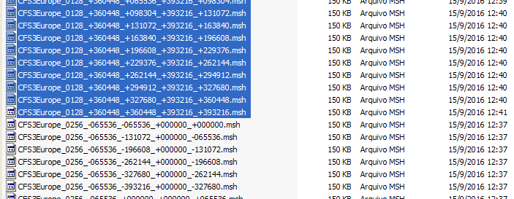
Click with right mouse button on selection and choose ADD TO FILE… Winrar option on popup menu.
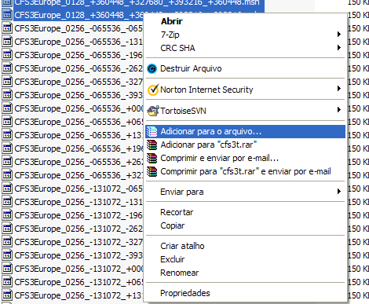
Name the file to cfs3msh1.zip. Choose the ZIP option and no compression option (store). Click OK
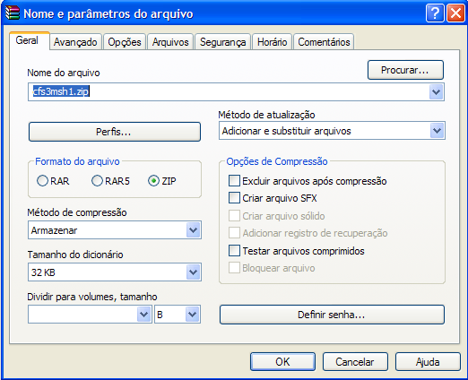
The cfs3msh1.zip is ready, but … do not copy to your new cfs3 theater installation yet…

Repeat the same process for the rest of MSH files:
LOD256 – ZIP files and name it cfs3msh2.zip
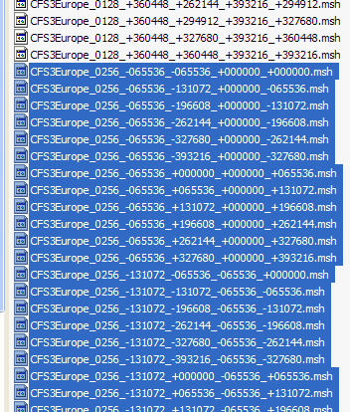
LOD512 to LOD32768 – ZIP files and name it cfs3msh3.zip
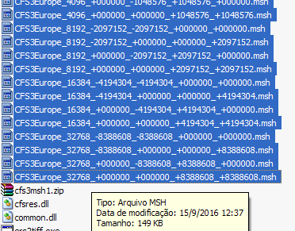
The 3 terrain mesh files required by the CFS3 are ready.

9.1-) Using the same process, ZIP the files for water areas.
- WATER
Open the Subdir MAKE_WATER on your working dir. Again, open the subdir hyl. Select all files and zip its with name cfs3hyl.zip. After ZIP, cut and paste cfs3hyl.zip to working dir root.
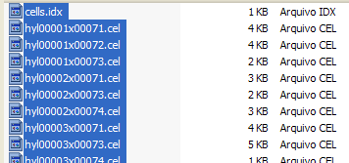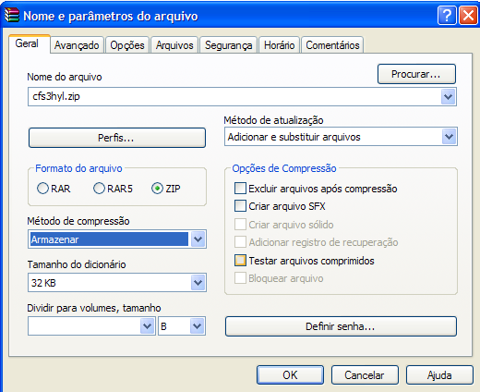

Now, open the subdir hyp and ZIP its with name cfs3hyp.zip. After ZIP, cut and paste cfs3hyl.zip to working dir root.
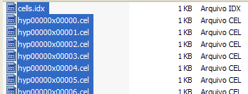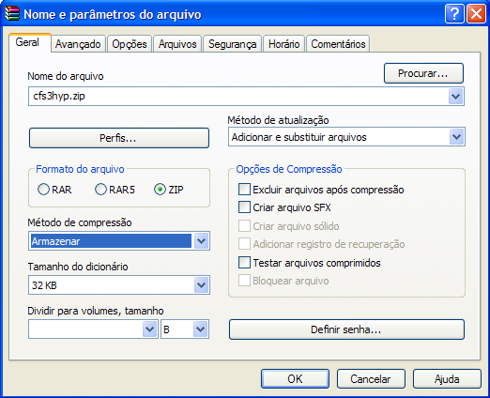

At this point the working dir must have all terrain MESH and WATER files ready.
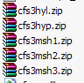
But, do not copy these files to new theater cfs3 instalation. Wait for next step.

9.3-) END OF STEP 9

